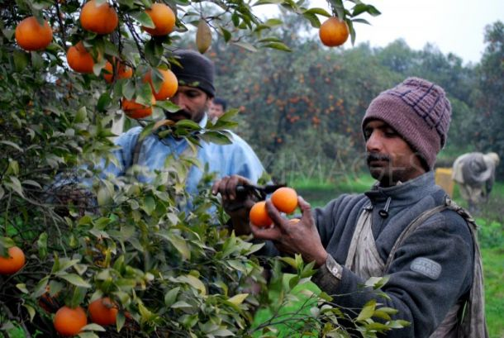

**SHAHID MALIK**

**(38 years)**

**Farmer of Orange and Pears**

**Land Ownership: 30 acres**

**Chak 10 GB, Bhera Sargodha**

Shahid Malik and his family in the business of growing oranges and pears for the last 50 years. They are known best for their production and cultivation of Oranges and Peers. Shahid himself have won the best ‘Per Acre Yield Award for orangs’ in 2015. He joined F2P network to introduce the world class pears and oranges in Pakistani markets. Prior joining to F2P plateform, his main passion was to export Oranges and Pears abroad to earn foreign exchange for the country but now he is part of value chain of F2P network.

You can also reach Shahid Malik directly at whatsapp: 0345 – 8550743